**1-(1-Adamyntyl)-1-methylethyl methacrylate**

**CAS Number:** [279218-76-7](https://www.chemicalbook.com/CASEN_279218-76-7.htm)

**Molecular Formula:** C17H26O2

**Molecular Weight:** 262.39 g/mol

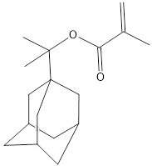

**Solubility:**

**Methanol** soluble