**5-oxo-4-oxa-5-homoadamantan-2-ol**

**CAS Number:** 79499-77-7

**Molecular Formula:** C10H14O3

**Molecular Weight:** 182.22g/mol

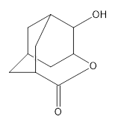

**Appearance……………………………………………….**Almost white to yellowish crystalline substance

**Purity, GC (IN)……………………………………………**min. 90.0 %