**1-(1-Adamyntyl)-1-methylethyl methacrylate**

**CAS Number:** [279218-76-7](https://www.chemicalbook.com/CASEN_279218-76-7.htm)

**Molecular Formula:** C17H26O2

**Molecular Weight:** 262.39 g/mol

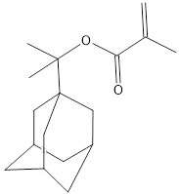

**Appearance……………………………………………….**Almost white to yellowish crystalline substance

**Purity, GC (IN)……………………………………………** min. 98.0 %